الاسم : عبدالله علاء الدين احمد عواد عبداللطيف

رقم الجلوس : 487 سكشن 22 جروب 4

الموضوع :computer architecture

Github link : <https://github.com/abdullah-alaa/html-project-repository>

Github page published website : <https://abdullah-alaa.github.io/html-project-repository/index.html>

Application brief

In this project we discuss the topic of computer architecture and briefly we can say that computer is programmable electronic device that accept data and peforms operations through input devices sush as ( keyboard ,mouse, scanner,…..etc) then presents the results through output devices sush as (monitors ,printers,…etc).

Also we can briefly mention the difference between main memory (ram) and storge .ram is faster and volatile but storage is lower and less volatile

Briefly we can mention the steps of the machine cycle :-

1-fetch

2-decode

3-execute

4-store

Screen shots

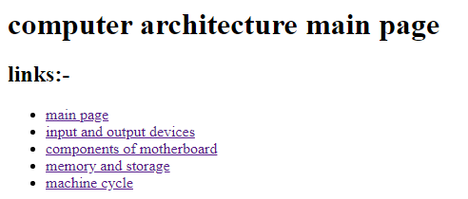

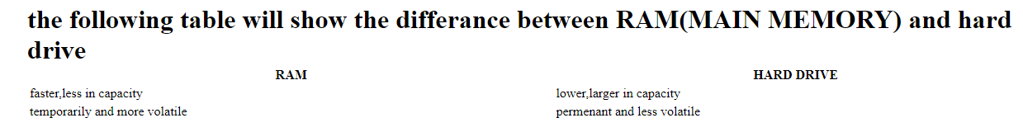

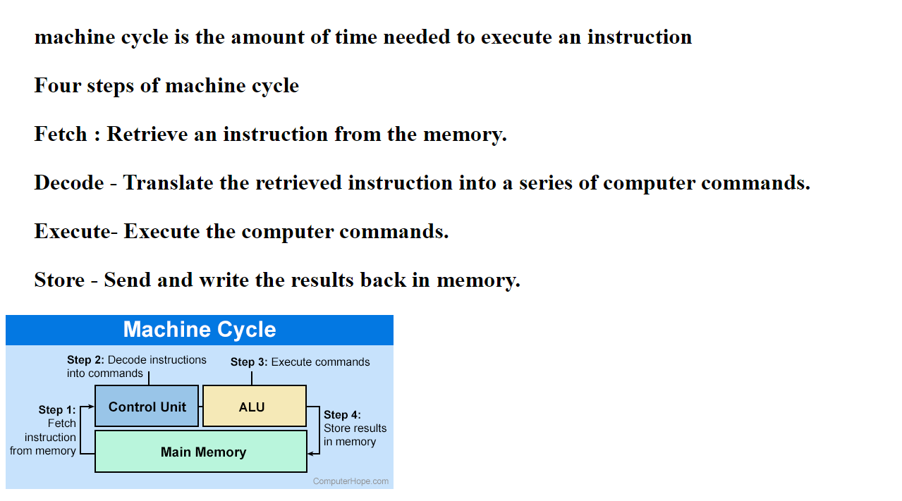

Source code :-

